Colin Maher K00186813

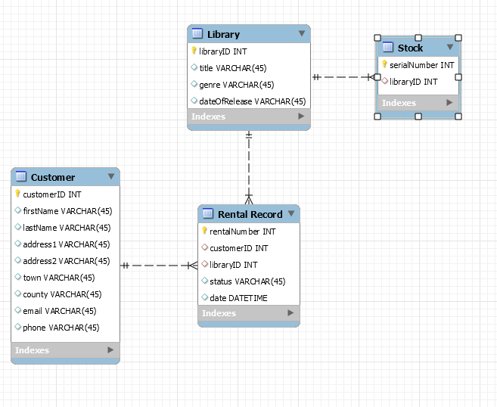

firstName 3NF

lastName 3NF

PK address1 3NF

customerID address2 3NF

town 3NF

county 3NF

email 3NF

phone 3NF

PK title 3NF

libraryID genre 3NF

dateOfRelease 3NF

PK

serialNumber libraryID 3NF

customerID

libraryID

rentalNumber status

date

customer = {customerID, firstName, lastName, address1, address2, town, county, email, phone}

library = {libraryID, title, genre, yearOfRelease}

rentalRecord = {rentalNumber, customerID, libraryID, status, date}

stock = {serialNumber, libraryID}